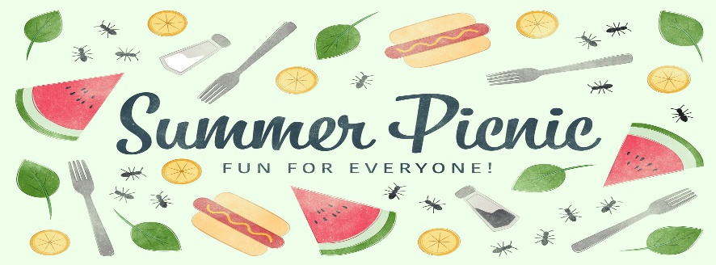
North Star Manor’s Picnic
Barn Dance
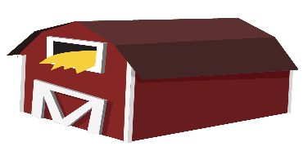
Sloppy Joes, Beans, Potato Salad, and
Rootbeer Floats
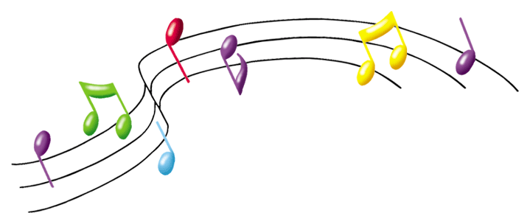
Music by Cathy Erickson
Thursday, July 11, 2019, at 5:00 pm
Entertainment 6:30 pm
Good Food, Good Friends, Good Times

