  - 410 S McKinley St Warren, MN 218-745-5282 Volume 1 Issue 3 Activities at North Star Manor September: We could not believe that summer was over, it went far to fast. September has the most birthdays of the year. We had 13! This includes North Star Manor, Assisted Living and Senior Apartments. The birthday party was hosted by First Lutheran of Stephen with a thoughtful reading by Pastor Schendel. The birthday breakfast was hosted by North Star Manor’s Mark and Carla Bichler on September 12. For entertainment, September 6th we had Bob Balyeat who sings gospel songs and plays different instruments. Theresa and the Plow Boys country western singers came on September 18^{th.} We finished up the month on September 26 with Larry Wheeler who has a wide variety of songs, some of which the residents love to sing along. In October: we had only five birthdays. The birthday party was hosted by Our Saviors of Argyle on October 9th. Mark and Carla hosted another wonderful birthday breakfast on October 17th. Entertainment started on October 13th with Lane Lindseth accordion/piano player and David Jeffery drummer. Lane goes to UND and is a music major. The music they play can be as long ago as Mozart or as early ’60s. It is so wonderful to hear. Our first Family Council was held on October 15 at 6:30 pm it was well attended and sometime in January will be the next meeting. Larry Wheeler came on October 18th to sing those love songs of the past. Cathy Erickson was great with the country western accordion music that the residents enjoy. The biggest day of the whole year here at North Star Manor is of course the Halloween Party that was held on October 31st. The residents love to pass out the candy and see the children in costume. We must have had over 200 children come for our residents to see. November: had four birthdays and the birthday party was hosted by St Rose of Argyle on Nov 6th. November 7 Dan Lee came and played his guitar and yodeled his country western music. Veterans Day Observance was held November 13th and was well attended and moving. November 19th was lefsa making morning. It was great fun and brought back many memories of making lefsa for the first time. The birthday breakfast on November 21 was made and hosted by Mark and Carla. Gobble til you Wobble was Thanksgiving Day with a delicious meal followed by Grab Bag Bingo. December: The Christmas Season brings a sense of anticipation. You just have a special feeling that lasts all month long. December 4 resident council was held. December 9th Julia Magnusson brought her piano students to entertain us with Christmas music. December 11 was the Birthday Party hosted by Our Savior’s Lutheran Church/Warren and the entertainment was great! On December 12 the birthday breakfast was held in the activity room and hosted by Mark and Carla. December 13 was our Christmas Service was beautiful and meaningful to all who attended. December 14th the Stephen/Argyle Elementary School first grade were awesome with their Christmas music. The Rusty Cord Trio were back on December 16 with the full sound of the Christmas songs we all remember and some new one too. December 18 Mona Schroder played the piano with the ability of an exceptional pianist. The beauty of the music was appreciated by everyone within listening distance. December 20th was North Star Manor’s Christmas Party. These Residents know how to party and Santa Clause was able to make the party too. Gifts, music (provided by Conrad Goroski) and food were available along with laughter and smiles. December 21 Chuck Gust called and asked if he could come and entertain on this date. He loves playing for our residents and I know you enjoy him too. December 22 Lane Linseth was here with his drummer to play for us. Others from the community came and sang carols in the hallways so everyone had a chance to hear the wonderful Christmas songs. Christmas Day was filled with family, friends and love.

Mark Bichler: Administrator
Carla Bichler: Social Work
Chris Dahlman: Director of Nursing
Debbie Sabol: Office Manager and Apartment Manager
Angela Poole: AL Housing Manager
Bev Erickson: HIM
Kelsey Kasprowicz: Director of Dietary
Jan Lamb: Chaplain
Cindy Engelstad: MDS, Infection Control
Renee Davis: Activity Director

September, October, November, December issue.
Tap here to add a caption

Season’s Greetings from the Social Work Case Management Department of North Star Manor. It will soon be one year that I have been working here in Warren. What a year of growth and adventure.
The resident council is having fun talking about paint colors and renaming of each hallway to make it more like a neighborhood. There will be splashes of color and interesting names that are familiar to our residents such as Cranberry Creek, Elderberry Avenue, and Plum Creek Station to name a few. We will be looking at signage and color coordination to assist both our residents and our visitors find their way more easily throughout the building.
Another monthly event that we have brought back is the “Birthday Breakfast”. Each month the residents who have a birthday during that month are invited on a day we select to eat in the activities room with residents from the nursing home, assisted living and senior living apartments. Some of the supervisors serve homemade pancakes and waffles from a family recipe and eggs to order with bacon and/or sausage. It’s nice to start the day in a small group setting and celebrate another year.
On October 15th the family council reconvened after a year. Cindy Engelstad, Infection Control RN provided an update regarding this year’s influenza vaccine and antibiotic stewardship. Mark Bichler, Administrator talked about the Minnesota Reimbursement system and how it is moving towards a cost-based system. One of the projects that we hope to move forward with includes fixing the nursing home roof.
The families in attendance shared their ideas for new services and fundraising ideas. In the future we hope to reach out in various methods i.e. letters, email, website and Facebook. They are also interested in hearing more from the residents about the decorating and involving new groups in the community as volunteers within the nursing home. Mark your calendars for Monday, January 14, 2019, 6:30 pm as we convene again and learn more together about what our residents, community and families need and want when it comes to senior services.
Thank you for the opportunity to be involved in your lives and community! Blessings, Carla Bichler, LSW

  - 2
  - 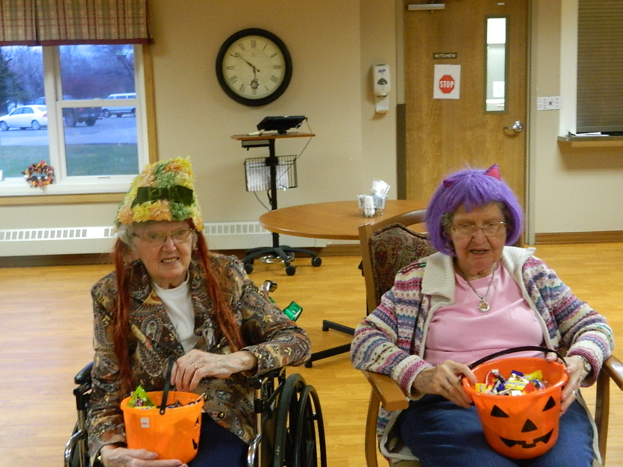 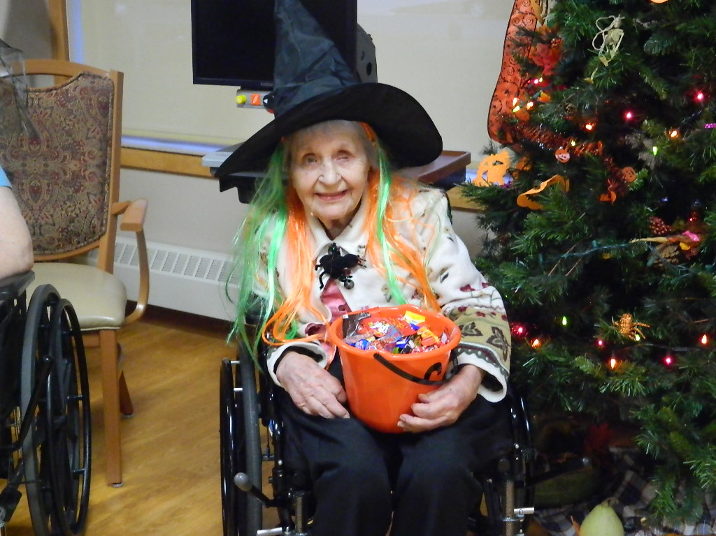 Halloween at North Star Manor
  - Janet Carlson and Marlys Kohlhase Darline Broten

  - 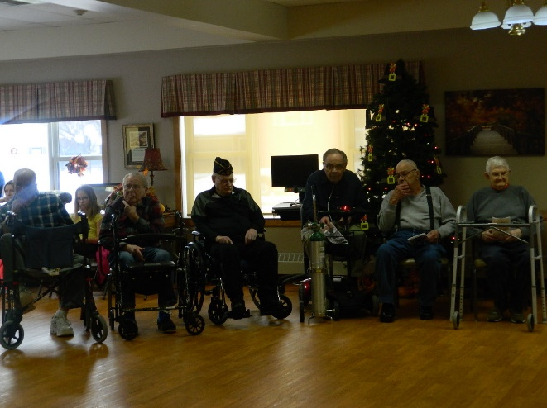 Veterans Day: Kenny Malm, Charles East, Bruce Rupp, Gene Johnston, Ray Burwell, Paul Knutson, Dale Folger, Joseph Deschene. Thank you for your service.

  - 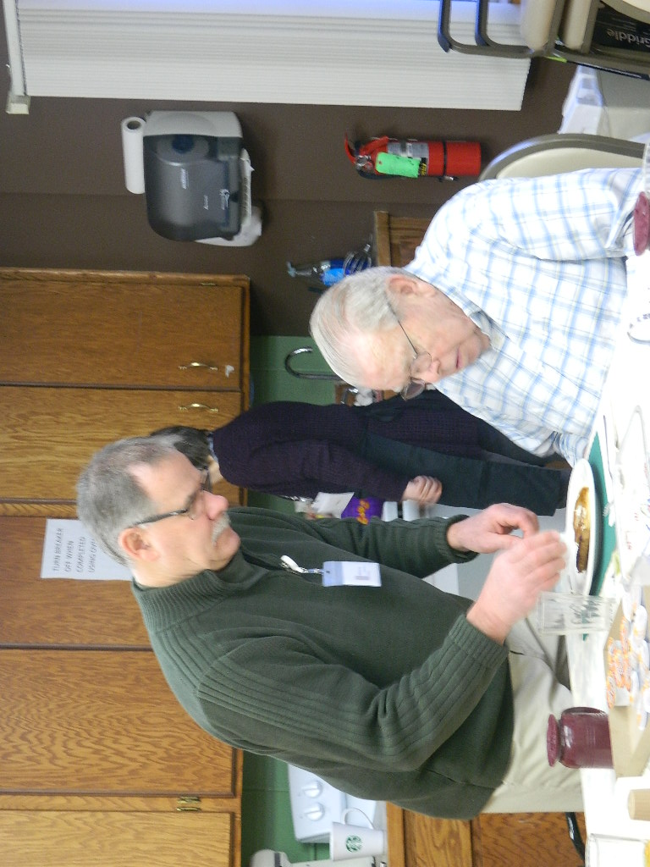 Mark Bichler serving Chuck East at Birthday Breakfast
  - Birthday Party with Chuck East and Gene Johnston

  - 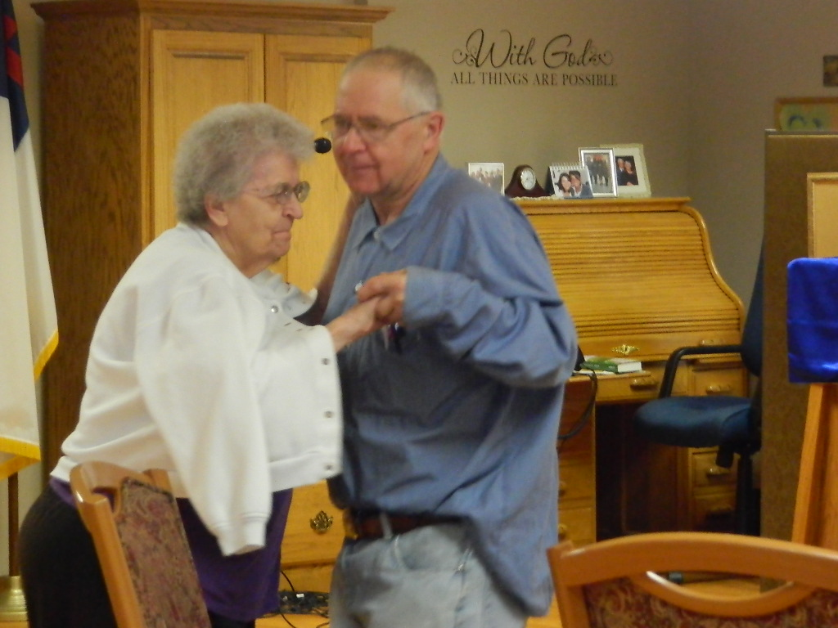 Emelia Novacek dancing with her son Jim to the music of Lane Lindseth accordion player.

  - 3

